Artificial and Computational Intelligence

ACI Assignment 1

1. Introduction
The objective of this assignment is to develop an intelligent agent capable of delivering relief supplies efficiently across various Ukrainian cities. The agent must navigate through safe paths while minimizing travel costs and ensuring battery efficiency.

2. PEAS (Performance, Environment, Actuators, Sensors)
Aspect | Description
Performance Measure | Minimize cost, optimize battery life, and ensure uninterrupted delivery.
Environment | Static, discrete, deterministic map of Ukraine along with path costs info.
Actuators | Movement across safe paths, delivery of supplies.
Sensors | Battery status, real-time path cost feedback.

3. Task Environment
The task environment for the Relief Supply Agent has the following properties:
- Observability: Fully observable, as the entire map and transportation costs are known beforehand.
- Deterministic: Actions lead to predictable outcomes.
- Discrete: Finite number of cities and connections.
- Static: Paths and costs remain unchanged during execution.
- Sequential : Next step of the agent will be dependent on the current state
- Single Agent: Single Agent Architecture

4. Heuristic and Fitness Functions
Random Restart Hill Climbing
Fitness Function: The sum of edge costs in a path. The lower the cost, the better the solution.
A* Algorithm
Heuristic Function (h): Estimated cost from the current city to the goal.
Fitness Function: f(n) = g(n) + h(n), where g(n) is the actual cost and h(n) is the estimated cost.

5.1 Random Restart Hill Climbing Algorithm
Random Restart Hill Climbing is a local search algorithm that avoids local optima by restarting from different initial states.
Steps:
1. Initialize an open list and add the start city.
2. Expand the city with the lowest total estimated cost (f = g + h).
3. Update neighboring cities and track the lowest-cost paths.
4. Continue until the goal city is reached.
5. Return the optimal path and total cost.

Flowchart:
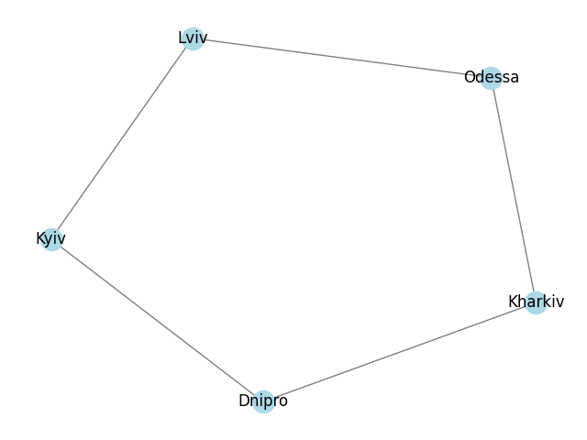

Example Execution:
Given Cities and Costs:
- Cities: Kyiv, Lviv, Odessa, Kharkiv, Dnipro
- Path Costs:
  - Kyiv → Lviv: 10
  - Lviv → Odessa: 20
  - Odessa → Kharkiv: 30
  - Kharkiv → Dnipro: 15
  - Dnipro → Kyiv: 25

Algorithm Execution:
- Start at Kyiv.
- Move to the neighbor with the lowest cost (Lviv, 10).
- Continue moving to lower-cost neighbors until reaching a local optimum.
- If stuck, restart from another random city.
- Repeat until the best possible path is found.
Final Path: Kyiv → Lviv → Odessa → Kharkiv → Dnipro → Kyiv Total Cost: 100

Python Code Snippet:
+------------------------------------+
# Random Restart Hill Climbing Implementation
def random_restart_hill_climbing(graph, start_node, restarts=10):
best_path = None
best_cost = float('inf')
for _ in range(restarts):
current_path = [start_node]
current_cost = 0
visited = {start_node}
while len(visited) < len(graph):
neighbors = [(neighbor, cost) for neighbor, cost in graph[current_path[-1]].items() if neighbor not in visited]
if not neighbors:
break
next_city, travel_cost = min(neighbors, key=lambda x: x[1])
current_path.append(next_city)
current_cost += travel_cost
visited.add(next_city)
if len(visited) == len(graph) and start_node in graph[current_path[-1]]:
current_cost += graph[current_path[-1]][start_node]
current_path.append(start_node)
if current_cost < best_cost:
best_path, best_cost = current_path, current_cost
return best_path, best_cost

5.2 A* Algorithm
A* is an informed search algorithm that finds the shortest path using a heuristic function to estimate cost.
Steps:
- Initialize an open list and add the start city.
- Expand the city with the lowest total estimated cost (f = g + h).
- Update neighboring cities and track the lowest-cost paths.
- Continue until the goal city is reached.
- Return the optimal path and total cost.

Flowchart:
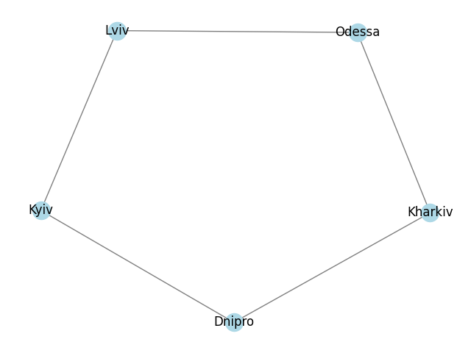

Example Execution:
Given Cities and Costs:
- Cities: Kyiv, Lviv, Odessa, Kharkiv, Dnipro
- Path Costs:
  - Kyiv → Lviv: 10
  - Lviv → Odessa: 20
  - Odessa → Kharkiv: 30
  - Kharkiv → Dnipro: 15
  - Dnipro → Kyiv: 25

Heuristic (h) Values:
- h(Kyiv) = 0
- h(Lviv) = 15
- h(Odessa) = 10
- h(Kharkiv) = 5
- h(Dnipro) = 0

Algorithm Execution:
- Start at Kyiv with f = g + h (g=0, h=0).
- Expand Kyiv and choose the neighbor with the lowest f value.
- Continue until reaching the goal state.
Final Path: Kyiv → Lviv → Odessa → Kharkiv → Dnipro → Kyiv Total Cost: 100

Python Code Snippet:
+------------------------------------+
# A* Algorithm Implementation
def a_star_algorithm(goal_node, heuristic, vertices, edges):
open_list = []
closed_list = []
heapq.heappush(open_list, (0 + heuristic[goal_node], goal_node, 0, heuristic[goal_node], [goal_node]))
while open_list:
f, curr_node, g, h, curr_path = heapq.heappop(open_list)
if set(curr_path) == set(graph.keys()) and curr_node == goal_node:
print("A* algorithm:")
print("Final Cost:", f)
print("Final Path:", curr_path)
return curr_path
closed_list.append(curr_node)
for neighbor, cost in graph[curr_node].items():
new_path = curr_path + [neighbor]
heapq.heappush(open_list, (g + cost + heuristic[neighbor], neighbor, g + cost, heuristic[neighbor], new_path))

6. Space and Time Complexity Analysis
Algorithm | Time Complexity | Space Complexity
Random Restart Hill Climbing | O(10 × V²) | O(V)
A* Algorithm | O(E log V) | O(E + V)

7. Simulation Outputs (Python Code Output)
- Input City : “Kiev”
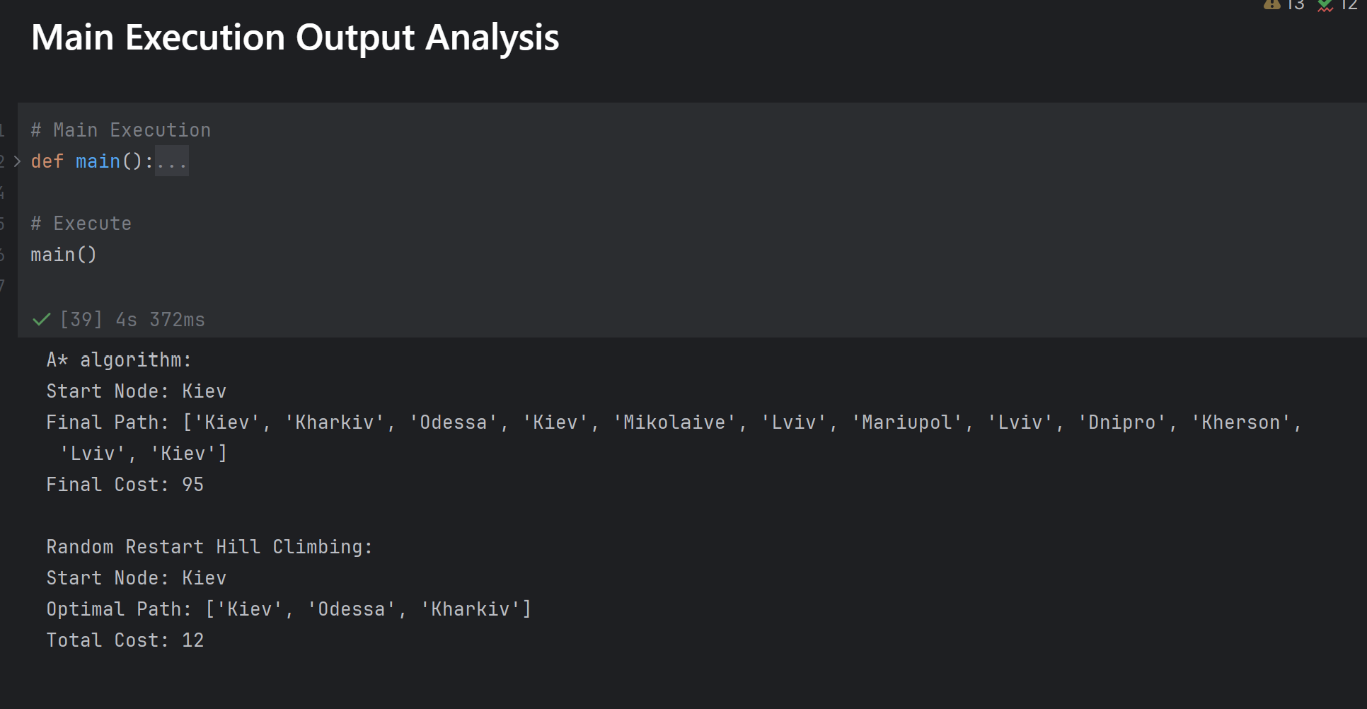
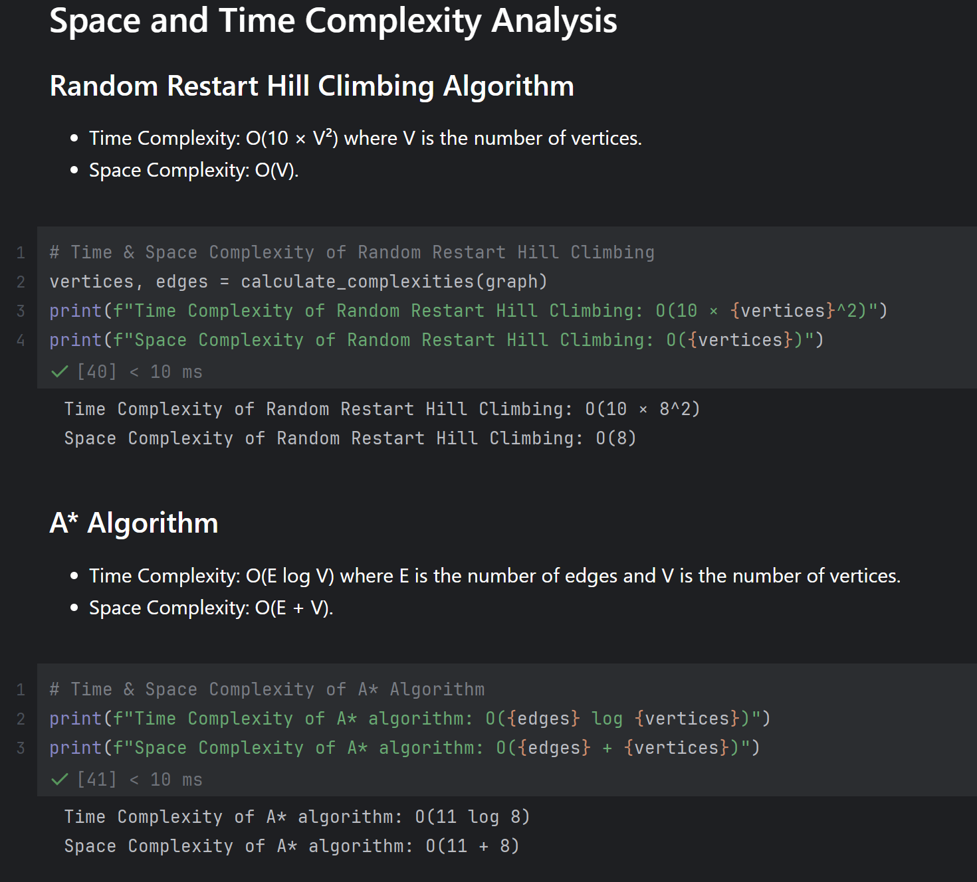
- Input City: “Mariupol”
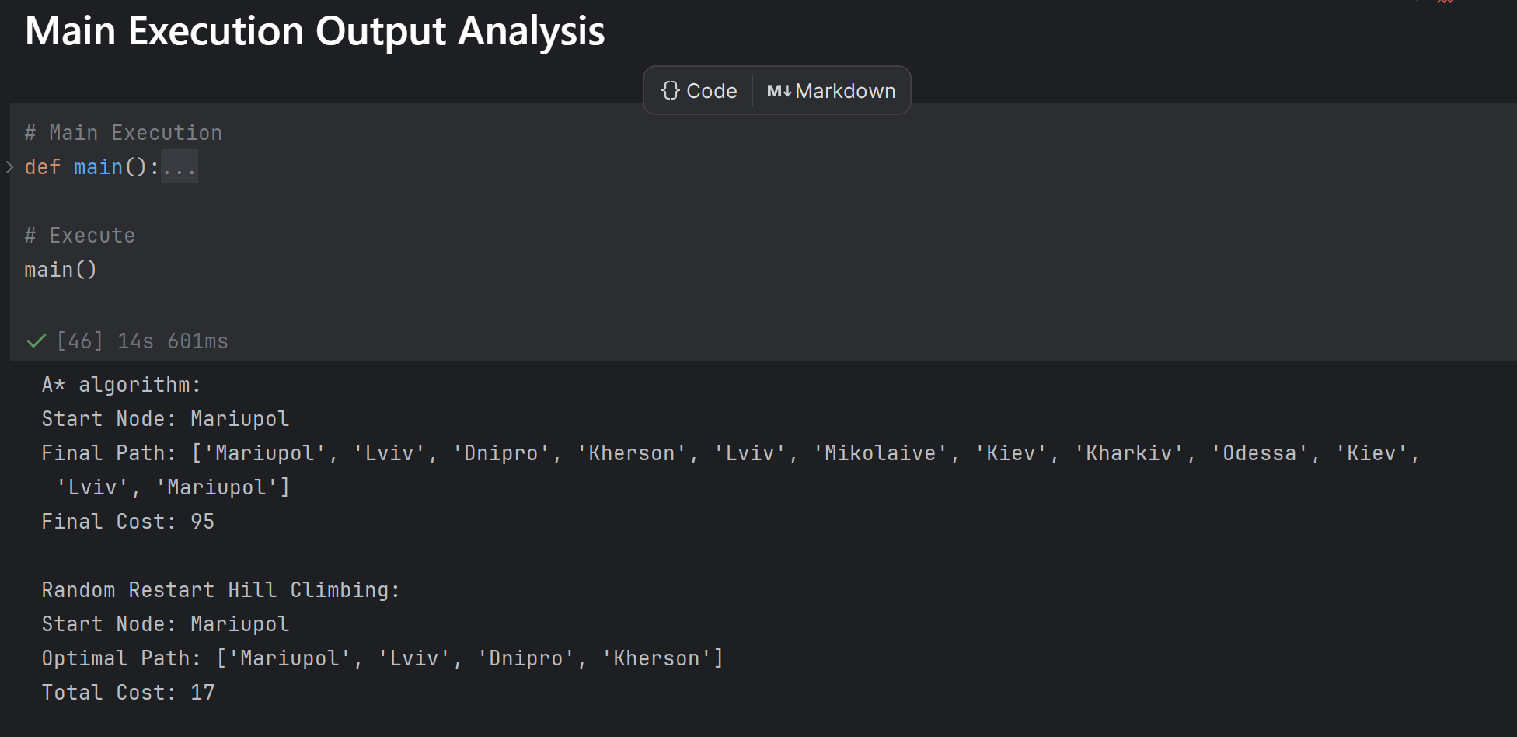
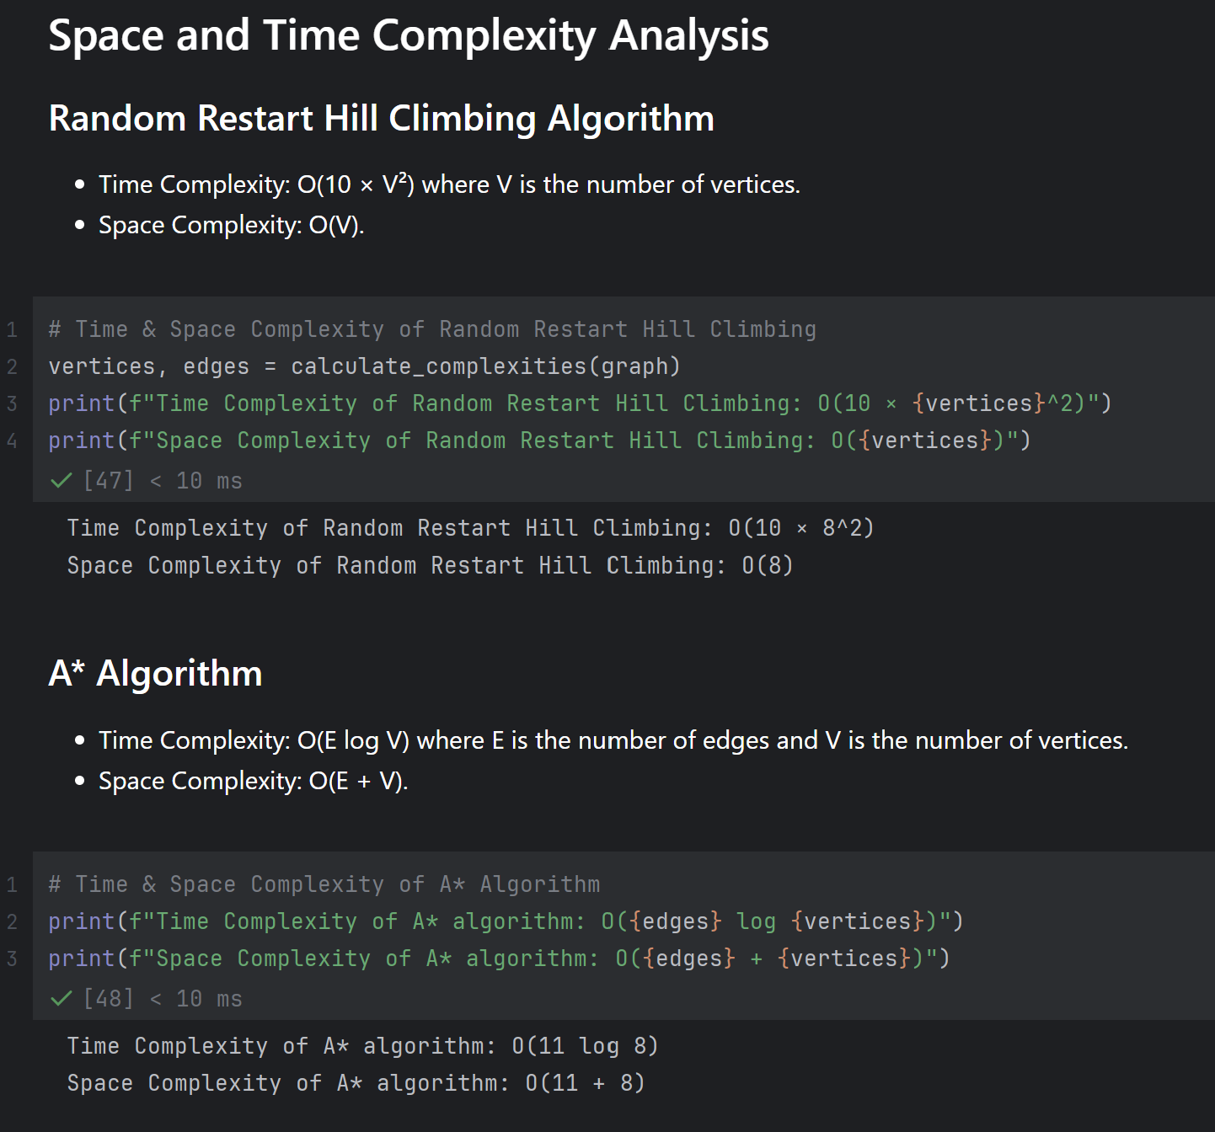
- Input City: “Dnipro”
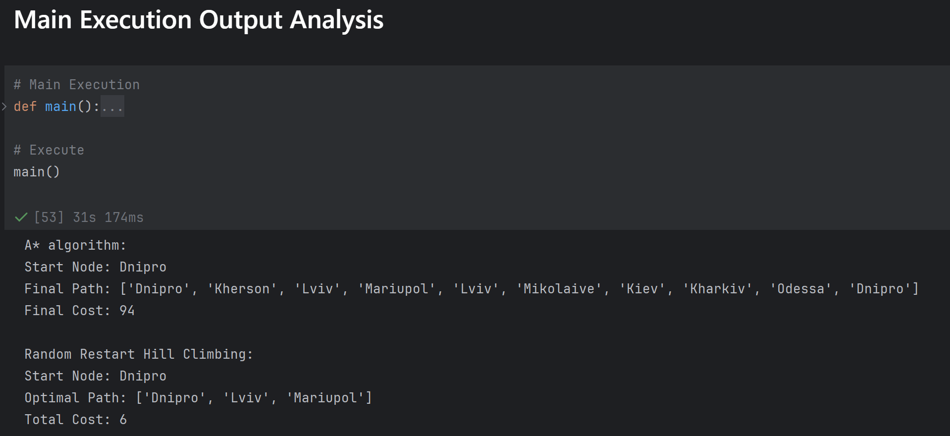
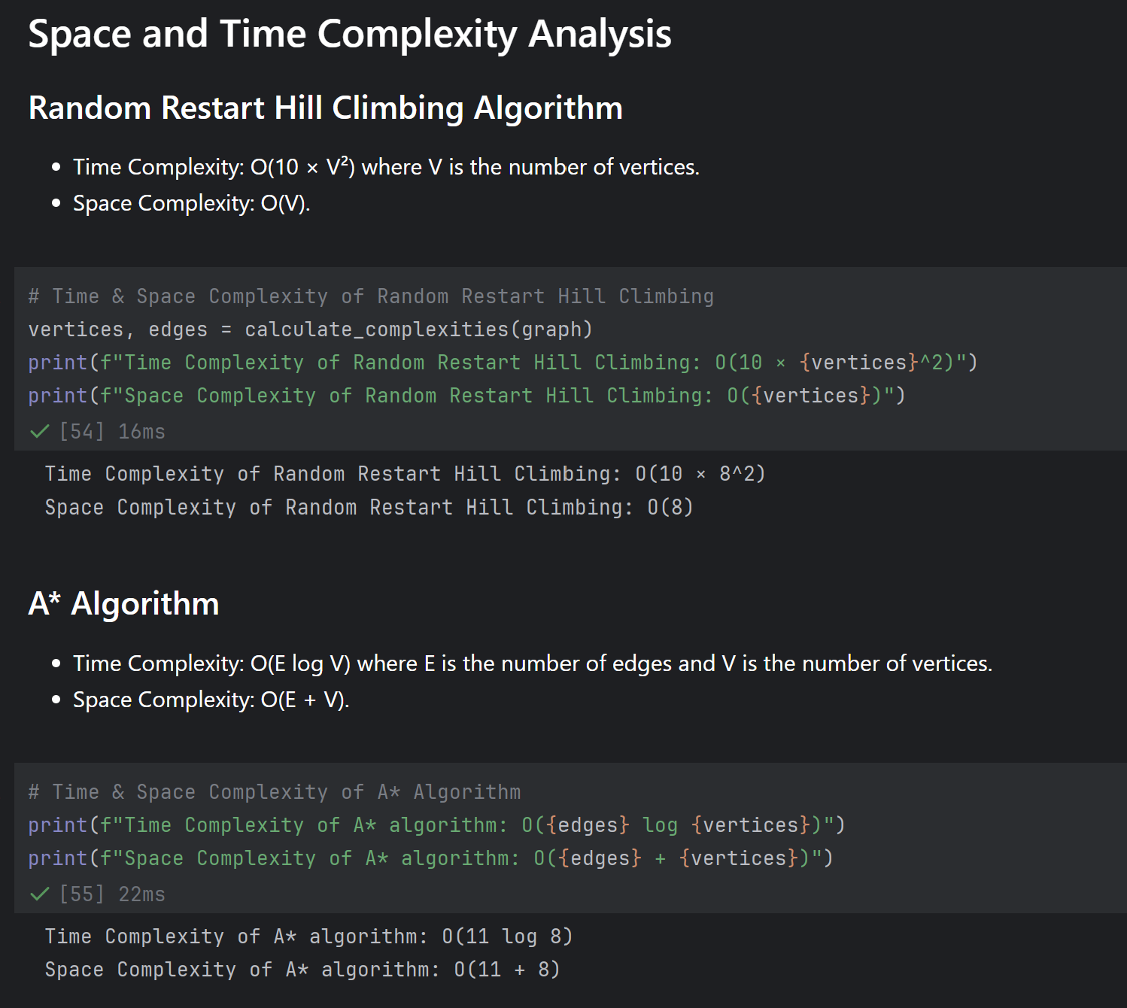

8. Team Members
BITS ID | Name | Contribution
2024AA05181 | Jagadi Shruti Chanabasappa | 100%
2024AA05182 | Prathyusha Devi K | 100%
2024AA05183 | A. Rohit Sai | 100%
2024AA05184 | Sarwajit Kumar Mishra | 100%
2024AA05185 | G V Ramya Sai | 100%

9. Conclusion
This project successfully implements an intelligent agent for efficient relief supply delivery using Random Restart Hill Climbing and A* Algorithm. While A* provides an optimal solution using heuristics, Hill Climbing explores multiple local optima to improve results.

